AWS RDS lab 5:

Step by step guide to connect a MySQL database to the ec2 instance.

Or

How to access MySQL Instance from Linux machine??

Step 1:login to the aws account and navigate to the RDS console.

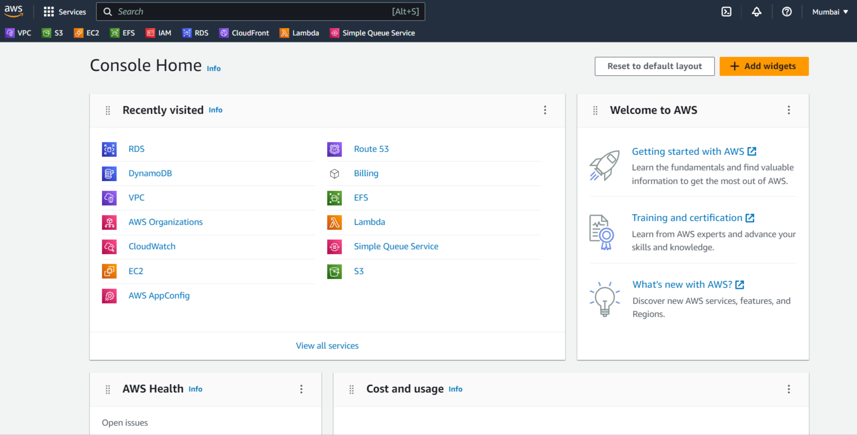

Step 2: select the MySQL database ,you want to connect to the ec2 instance.

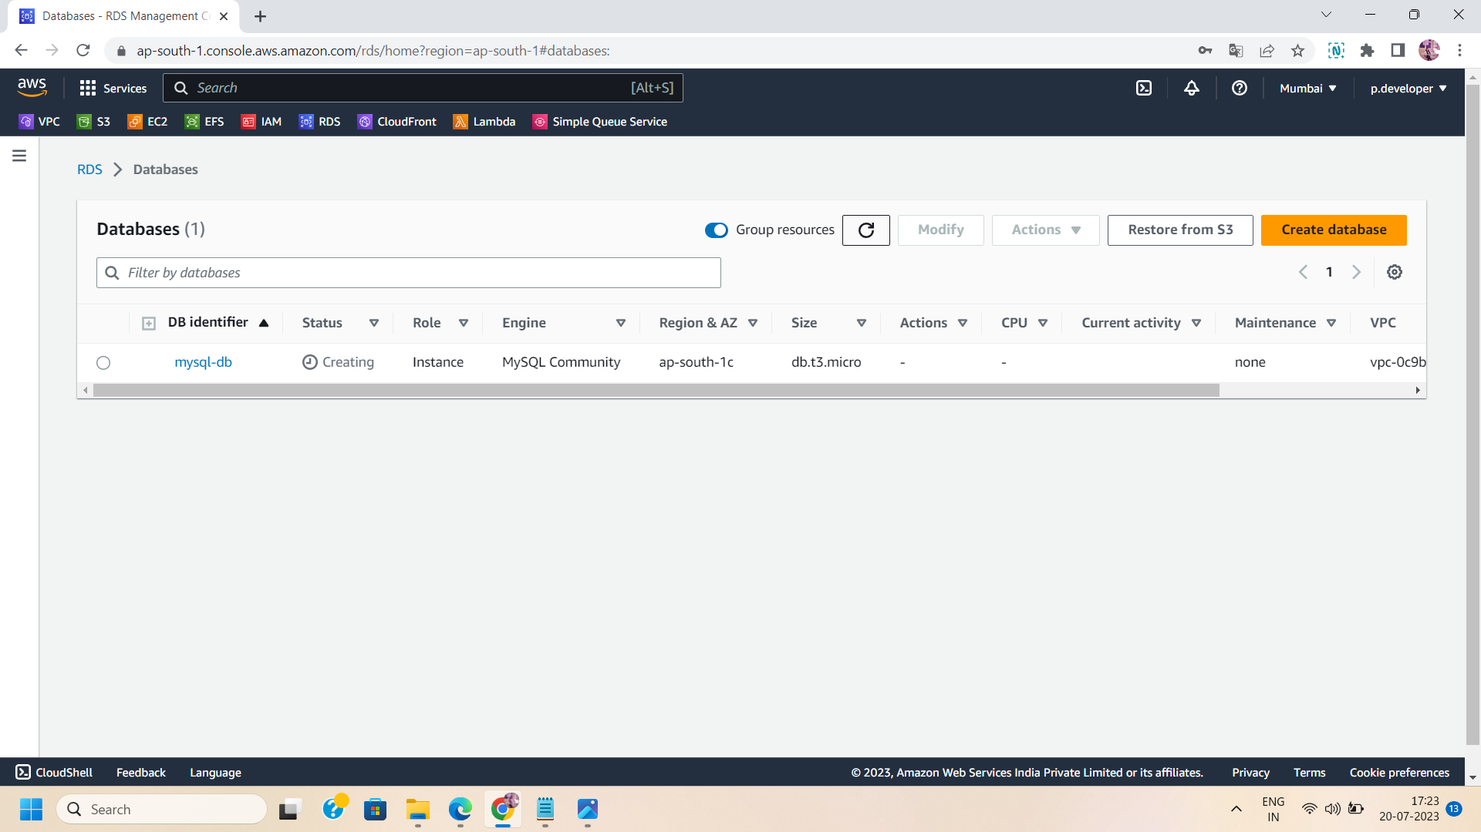

Step 3: Edit the security group:

The security group used in mysql database,should have SSH traffic allowed as inbound rules.If not then edit the security group and manually add the inbound rule.

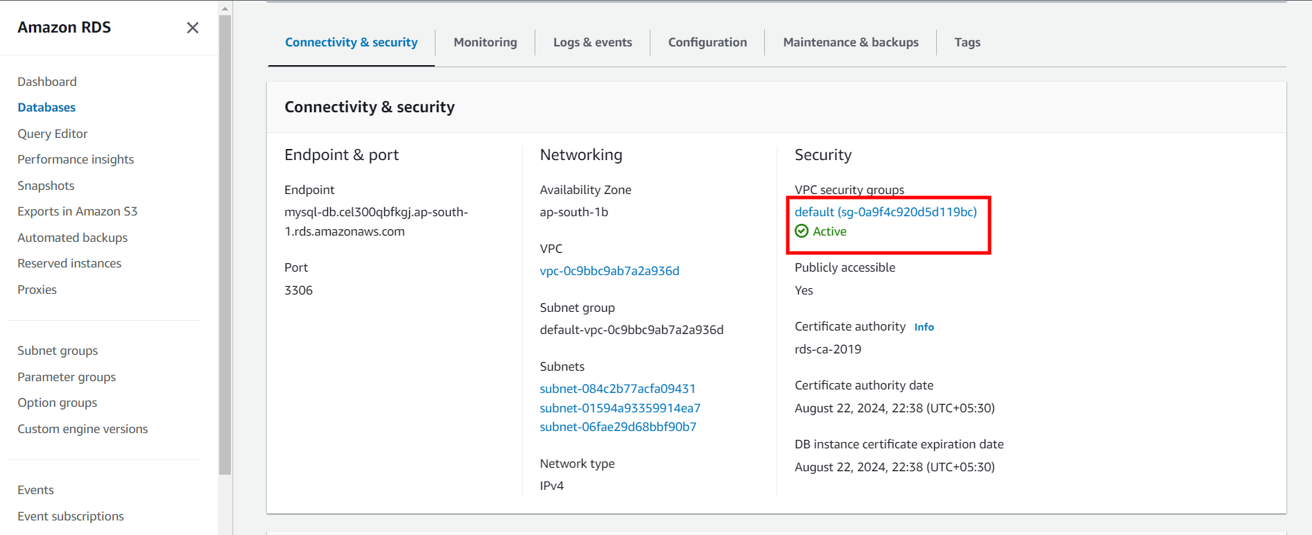

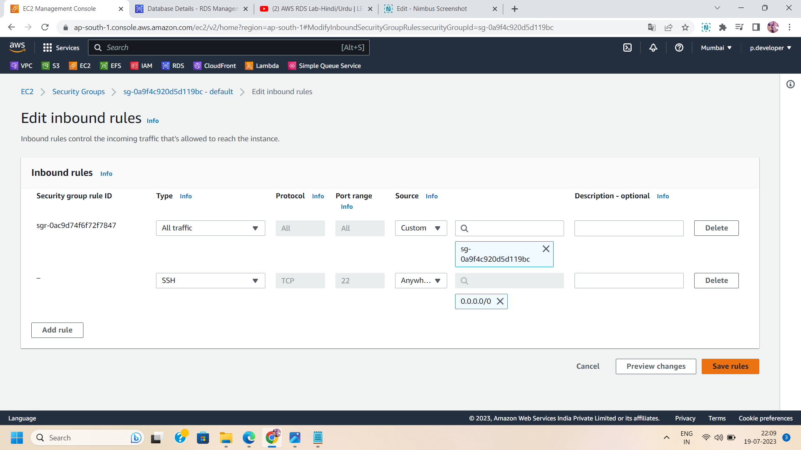

“

Step 4:Go to the ec2 dashboard and click on “launch instance” to launch an instance.

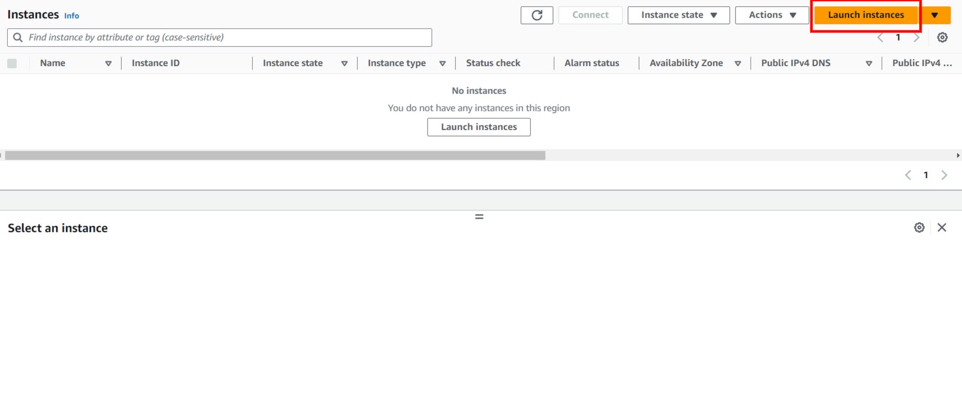

Step 5:Name the instance and select the linux AMI.

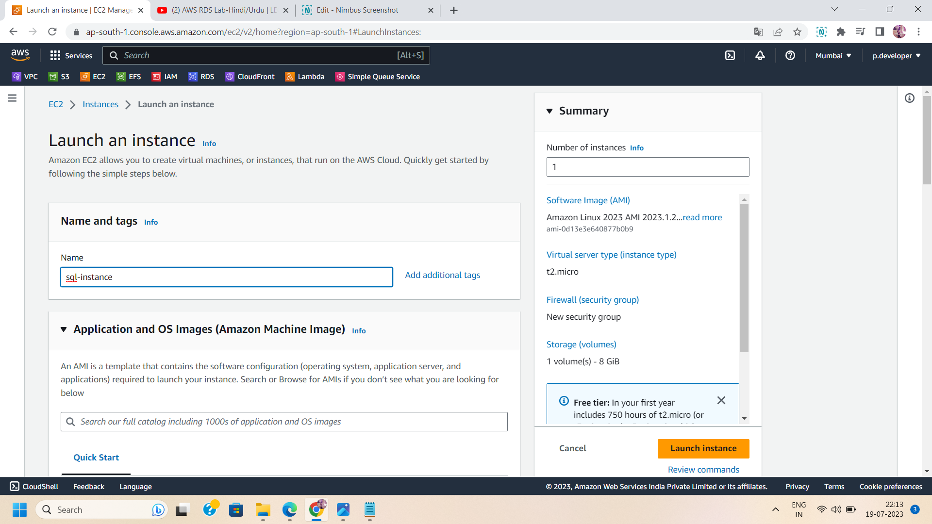

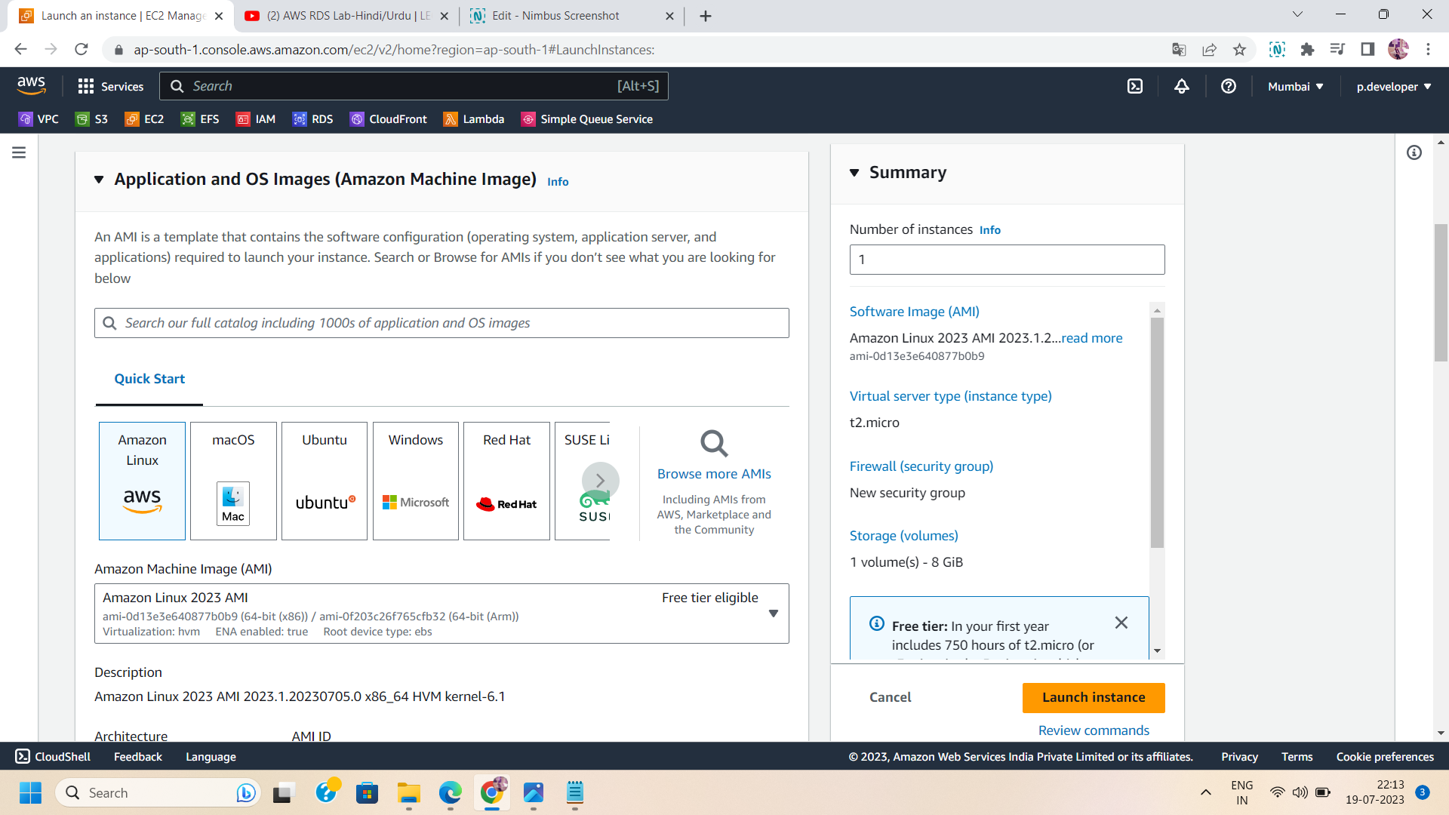

Step 6: Select the key pair and configure networking settings.Make sure, you select the same security group that you use in creating MySQL database.

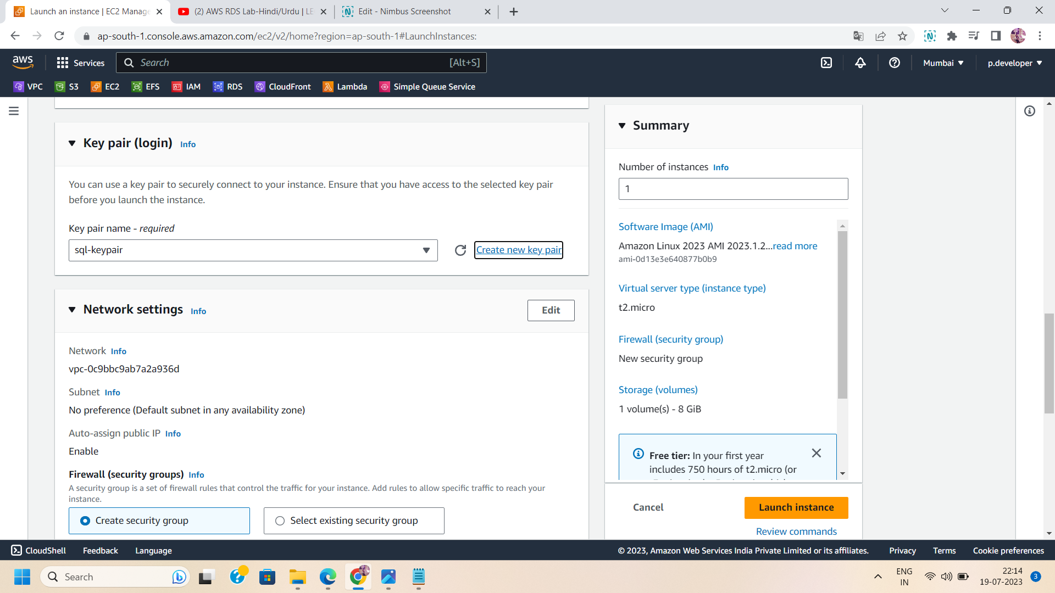

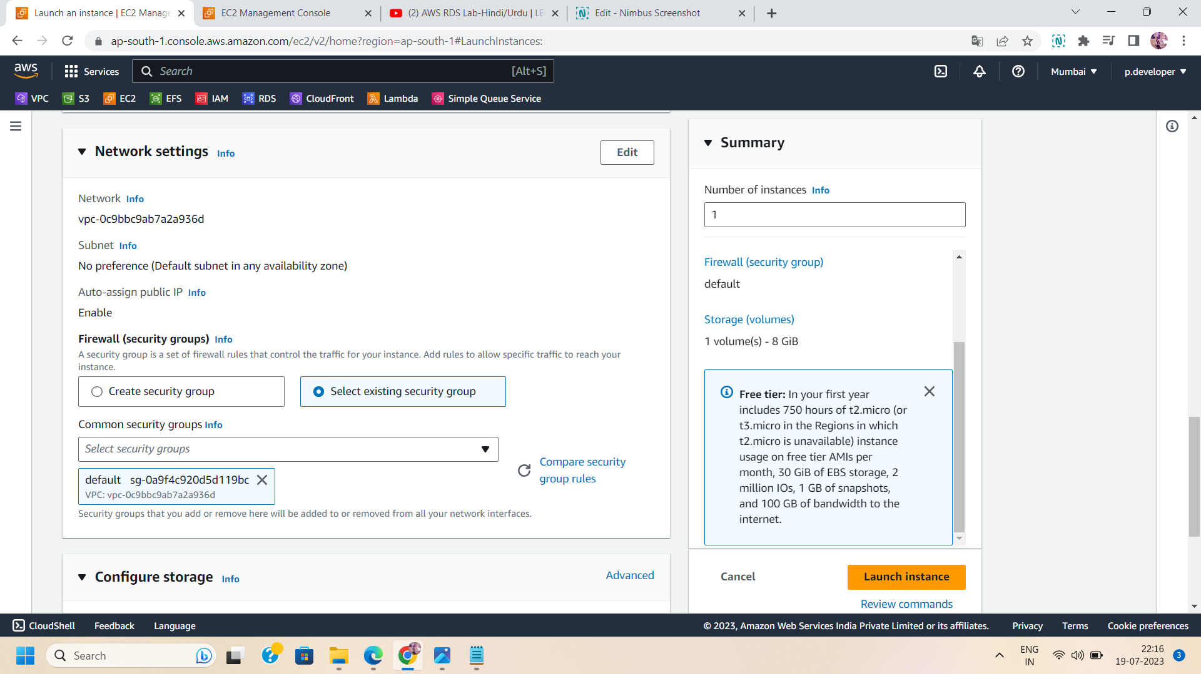

Step 7: then launch the ec2 instance.

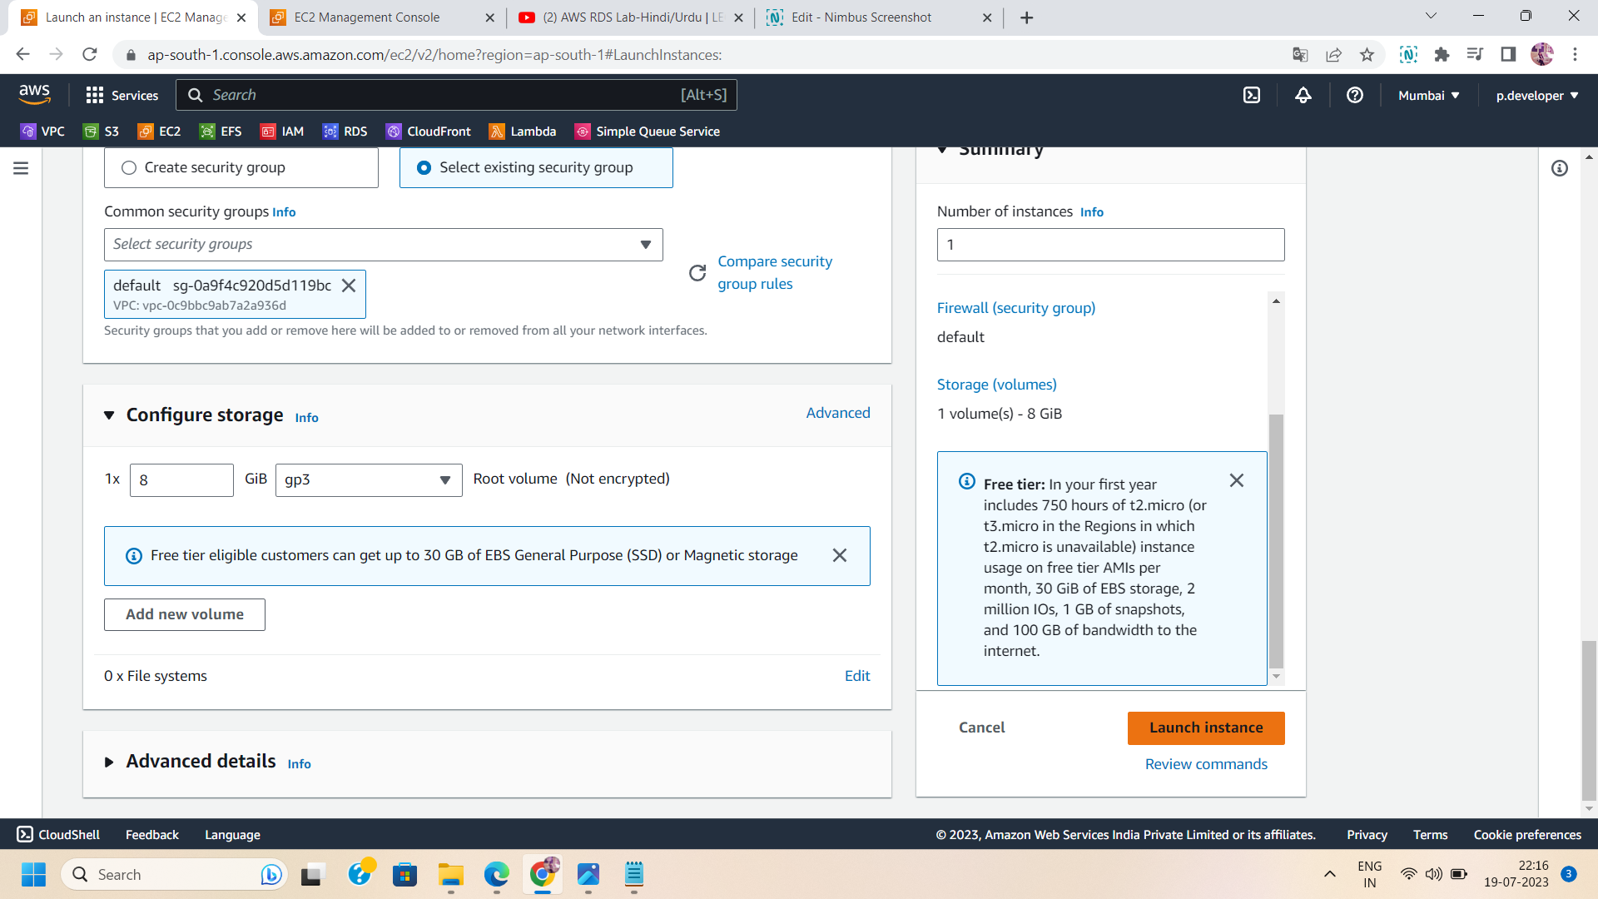

Step 8: Download the MySQL : use SSH related software to take ssh of the ec2 instance,like putty and login as ec2 user.Then install the mysql server using the following command :

Sudo su -

yum install -y mysql

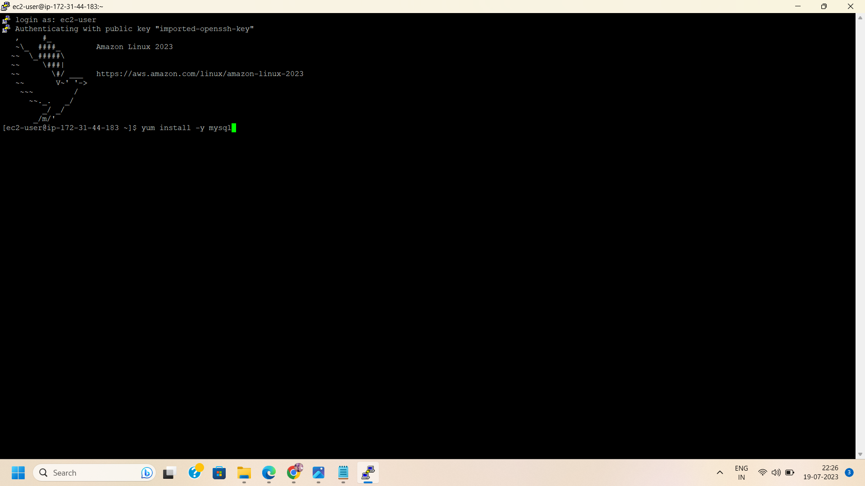

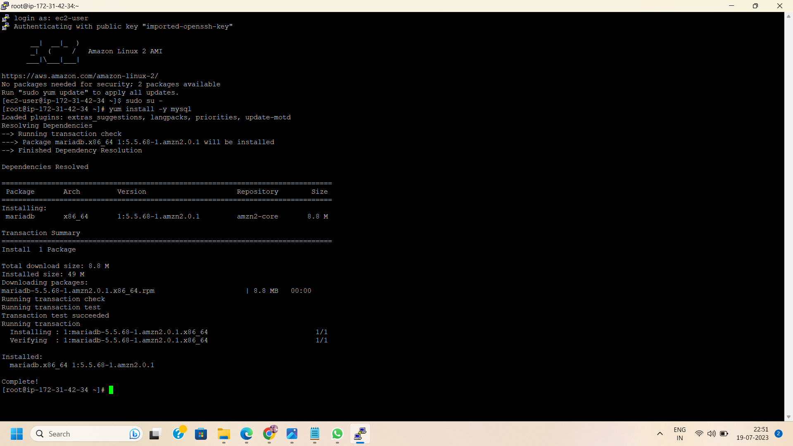

Step 9: After installing the mysql server in linux,login into mysql using mysql database end-point. Run the following command :

mysql -h <MySQL database end-point> -u <USERNAME> -p <DATABASE NAME>

Where username is the name used at the time of database creation as master username.

And database name is the name used in the additional configuration as initial database name.

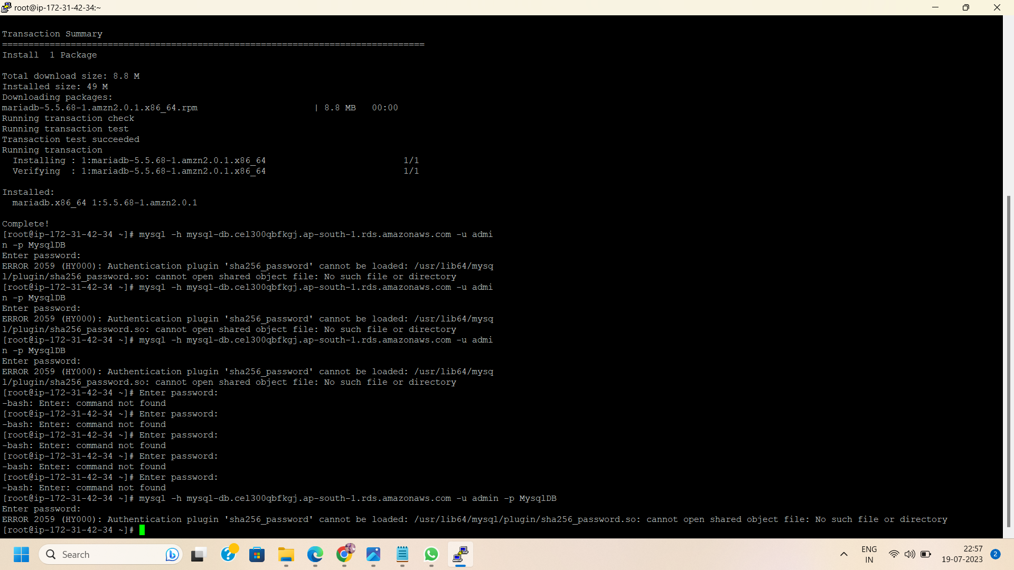

Step 10: Access MySQL Instance :

After successfully running the above command,enter the password that was created at the time of MySQL database creation.Immediately after entering the password ,mysql server will be open and can be accessed to run mysql queries.

